Hike Your Way to Inspiration
Ever find yourself stuck on a difficult piece of code? Or perhaps you’ve had too much screen-time for one week! If so, we’ve got the perfect way for you to blow off some cobwebs and find some inspiration for the week ahead.
Read on to see how you can explore Ireland - and shake off any brain-melting problems – with a brisk hike or walk around some of the country’s most picturesque trails.
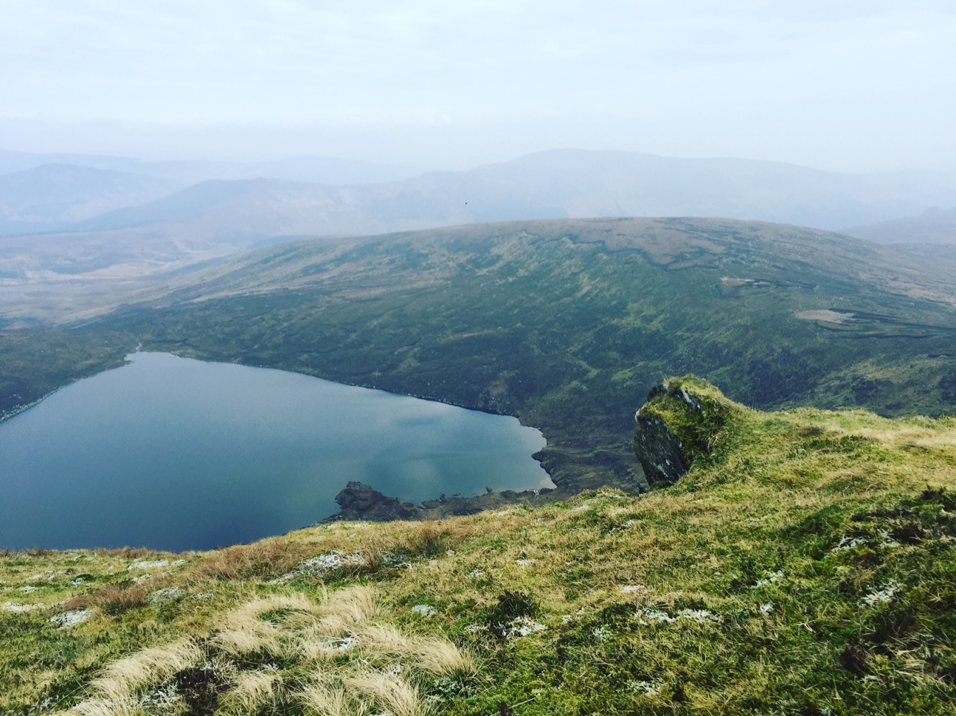
[alt text: A view of Lough Ouler on a Wicklow hike]
Step off the Beaten Track in Wicklow
Just one hour from the bustle of Dublin, Wicklow’s hill and mountain ranges offer the perfect sanctuary from your work schedule. Heading out of the city towards the picturesque Glendalough, you’ll find a variety of trails to suit hikers of any level. A former glacial valley, it now welcomes thousands of visitors a year who revel in the area’s natural splendour. Make the most of your day, by heading online to plan your approach before your visit, and choose your trail for the day. Guided walks are available if you want to enjoy some commentary as you hike.
Or if you’d like to take in scenery away from the crowds, head for Tonelagee and enjoy the views as you scale Ireland’s 33rd highest mountain. A steep climb to the summit, the effort will pay off as you’ll be rewarded with a vista that takes in one of the area’s stunning corrie lakes, Lough Ouler. On a good day, you may even catch a glimpse of the legendary Snowdonia in nearby Wales.
Along with a host of stunning trails, there are a number of walking clubs who regularly head out into the hills. Check out the Wayfarers Association and The Ramblers Club for more information on regular excursions and walks.
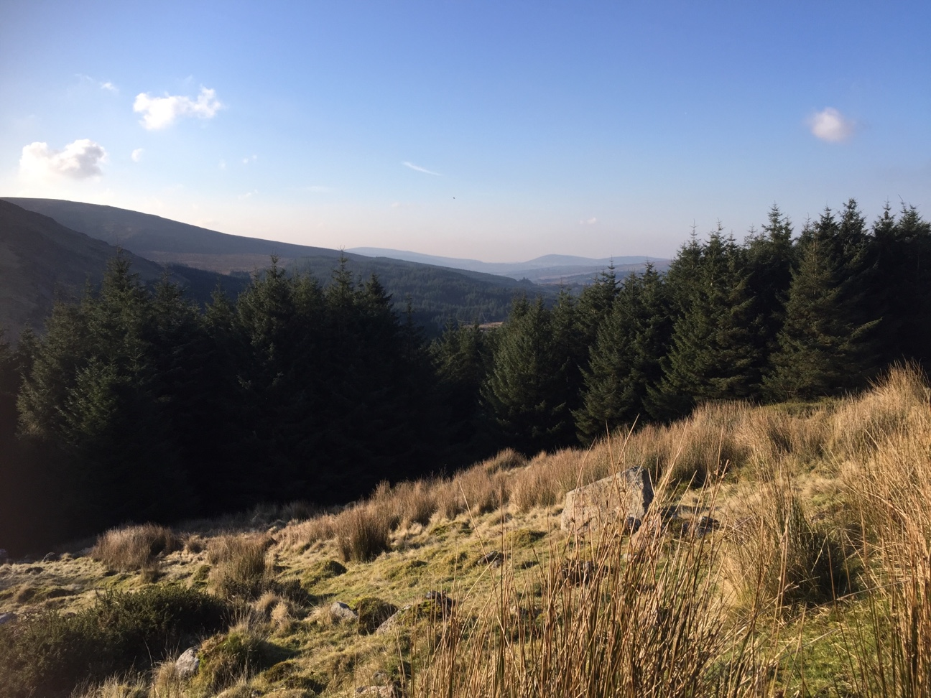
[alt text: Wicklow hikes boast beautiful views]
Explore West Cork
Based in Cork City? Then you’re in the perfect location to explore some of the best parts of the country with West Cork and the south coast close to your doorstep. If you love history, head for Gougane Barra. Once the home of St. Finbar – who is said to have built his monastery on the island in the 6th century – the area now boasts one of the country’s most picturesque churches. And while it’s a regular stop for newly-weds, if you fancy a walk in the stunning surrounds you’re in luck, as the Gougane Barra Forest Park boasts an array of walking and cycling trails.
Elsewhere, The Galtees and The Comeraghs are popular destinations for hill-walkers. Want to combine your hike with a chance to meet some locals? Then, check out this guide to local walking or mountaineering clubs you can join.
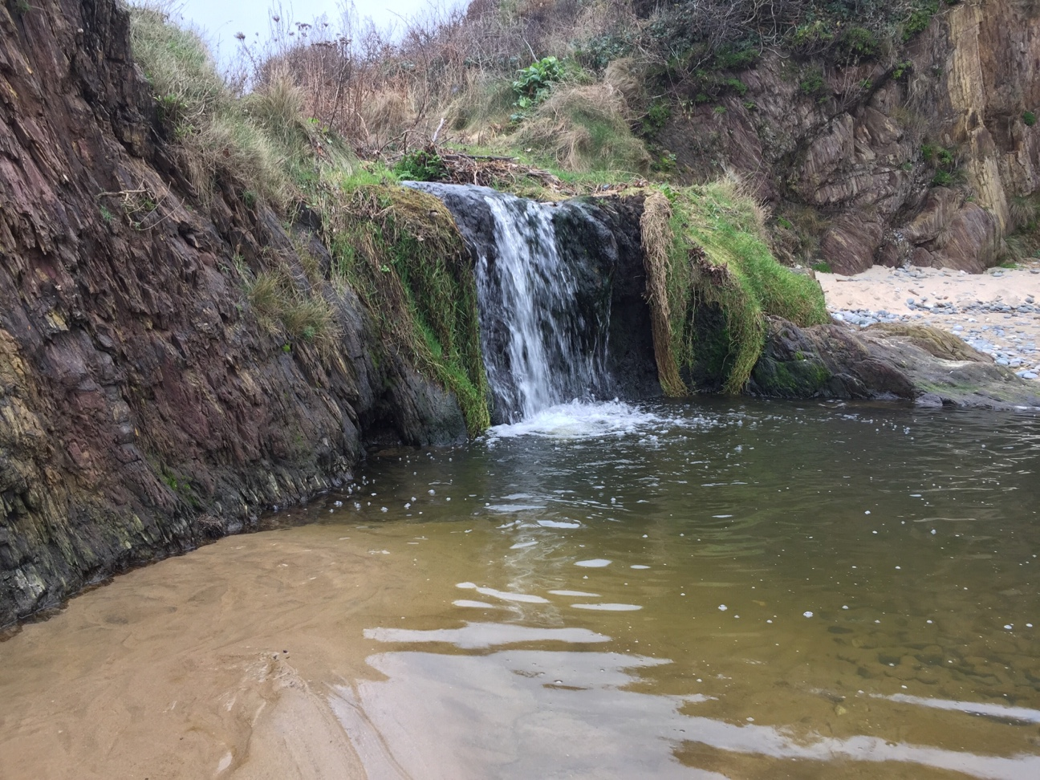
[alt text: Hiking clubs offer group walks in local areas]
Head into the Wild West
Towards the West, Galway’s tech hub is located within reaching distance of the West’s many walking and hiking trails. If you’ve got time to spare, opt for the Western Way and break up the 50 kilometre route with picturesque stops at Maumeen, Inagh and the Twelve Bens.
For the weekend hiker, a trip to Suck Valley will offer a 10 kilometre tour of the area and give you the chance to soak in the sounds and sights of the countryside. Just follow the marked signs for the walkway and take the chance to explore the Ballintober and Dunamon areas. Or if you have access to a car, head into Connemara and combine a hike with the chance to take in one of Ireland’s most beautiful areas in the Connemara National Park.

